Database Testing (ai_saas_db)
Test Report BY Masuduzzaman Niloy

Part A - Schema & Structural Validation

A1. List all tables & document users and usage_logs columns.

Step 1 - List all tables
SHOW TABLES;

Expected output:
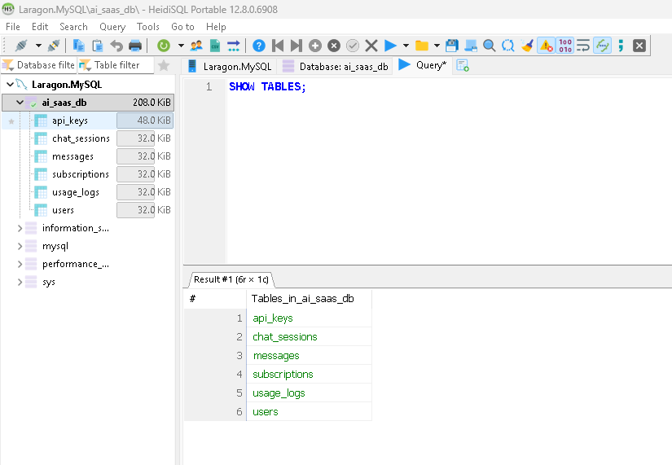

Step 2 - Document user’s columns
DESCRIBE users;
SELECT COLUMN_NAME, COLUMN_TYPE, IS_NULLABLE, COLUMN_KEY, COLUMN_DEFAULT
FROM information_schema.COLUMNS
WHERE TABLE_SCHEMA = 'ai_saas_db' AND TABLE_NAME = 'users';
Expected output:

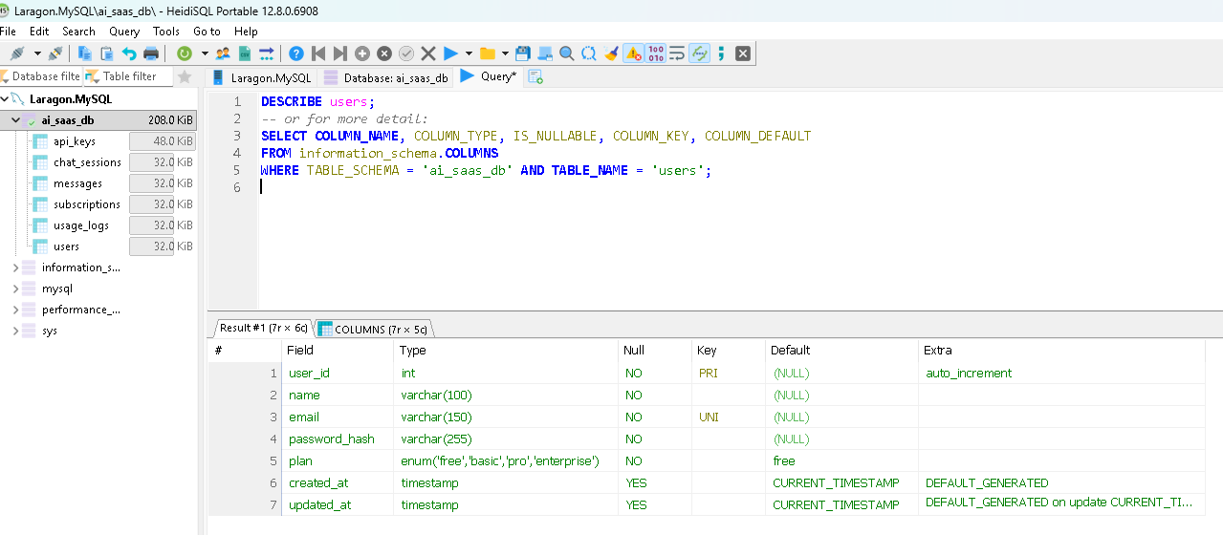

Step 3 - Document usage_logs columns
DESCRIBE usage_logs;
Expected output:

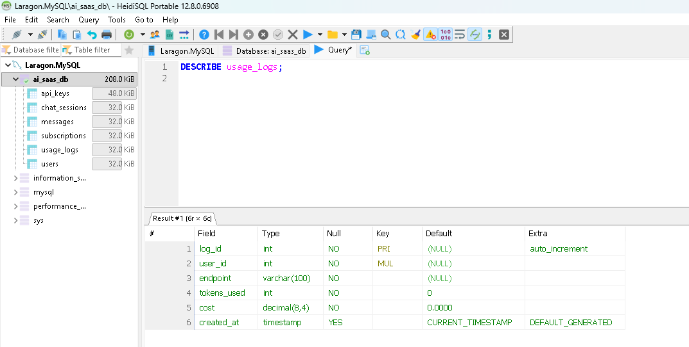

A2. Verify primary keys and foreign keys exist

Step 1 - Check primary keys
SELECT TABLE_NAME, COLUMN_NAME, CONSTRAINT_NAME
FROM information_schema.KEY_COLUMN_USAGE
WHERE TABLE_SCHEMA = 'ai_saas_db' AND CONSTRAINT_NAME = 'PRIMARY';
Expected output:
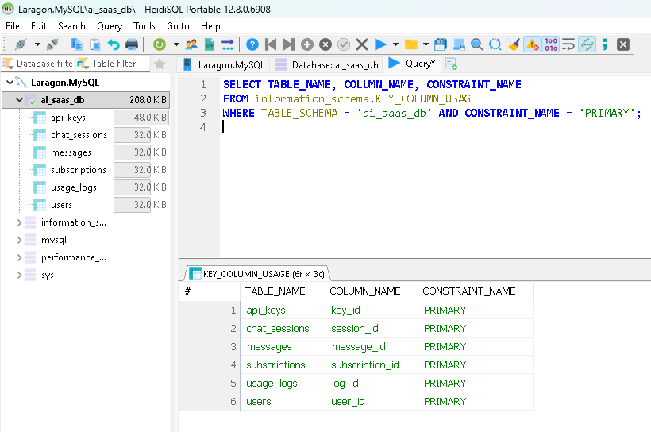

Step 2 - Check foreign keys
SELECT TABLE_NAME, COLUMN_NAME, CONSTRAINT_NAME, REFERENCED_TABLE_NAME, REFERENCED_COLUMN_NAME
FROM information_schema.KEY_COLUMN_USAGE
WHERE TABLE_SCHEMA = 'ai_saas_db' AND REFERENCED_TABLE_NAME IS NOT NULL;
Expected output:

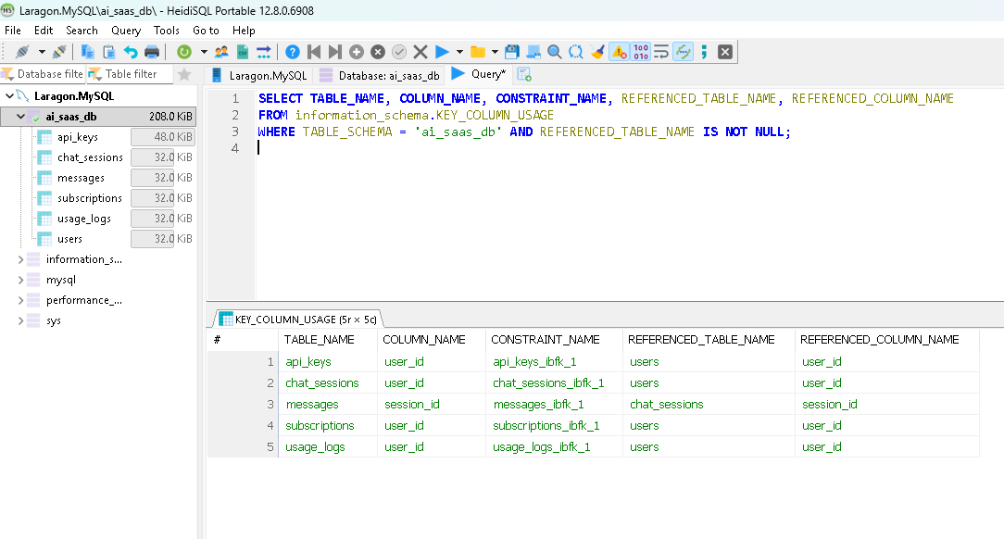

A3. Confirm users.email uniqueness and users.plan restricted values

Test 1 - Email uniqueness
-- Attempt to insert a duplicate email (assumes user with this email already exists)
INSERT INTO users (name, email, password_hash, plan)
VALUES ('Duplicate Test', 'existing_user@example.com', 'hash123', 'free');
Expected result: ERROR 1062 (23000): Duplicate entry 'existing_user@example.com' for key 'users.email' -confirms the UNIQUE constraint is active.

Test 2 - Plan restricted values
INSERT INTO users (name, email, password_hash, plan)
VALUES ('Platinum Test', 'platinum_test@example.com', 'hash123', 'platinum');
Expected result:
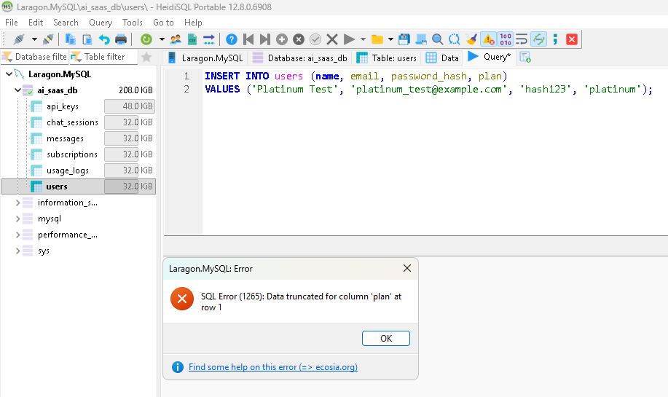

Part B - CRUD & Constraint Testing

B1. Create - insert a valid new user
INSERT INTO users (name, email, password_hash, plan)
VALUES ('Rafiq Islam', 'rafiq.islam@example.com', 'hashed_pw_001', 'free');

SELECT * FROM users WHERE email = 'rafiq.islam@example.com';

Expected result:
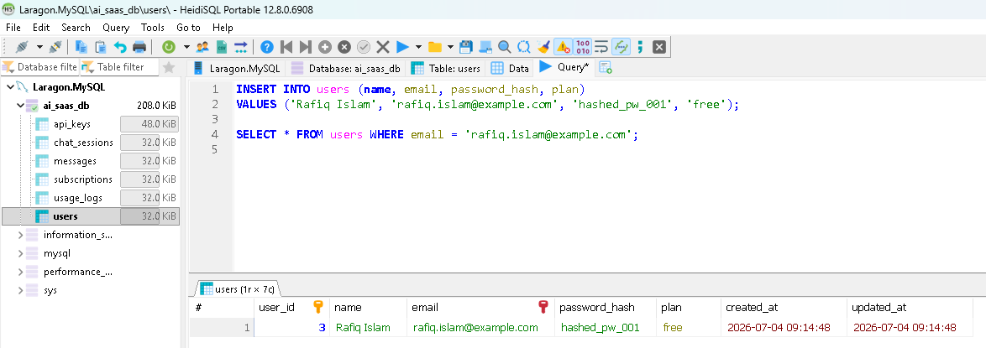

B2. Create (negative) duplicate email
INSERT INTO users (name, email, password_hash, plan)
VALUES ('Fake Rafiq', 'rafiq.islam@example.com', 'hashed_pw_002', 'basic');
Expected result:
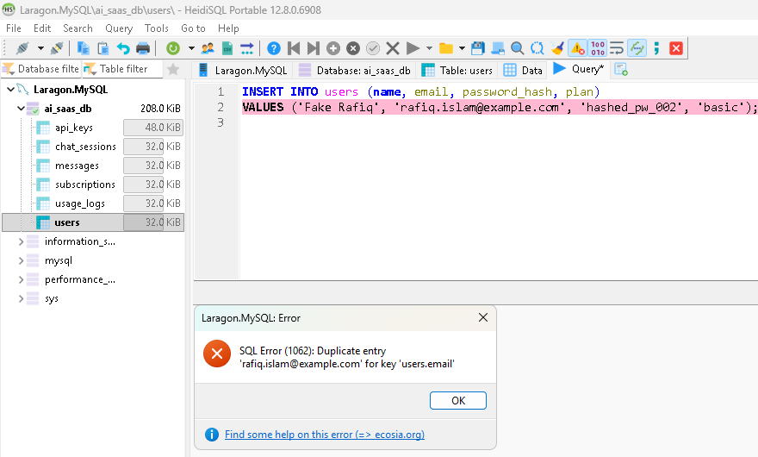
B3. Create (negative) invalid plan value
INSERT INTO users (name, email, password_hash, plan)
VALUES ('Test Platinum', 'platinum2@example.com', 'hashed_pw_003', 'platinum');

Expected result:

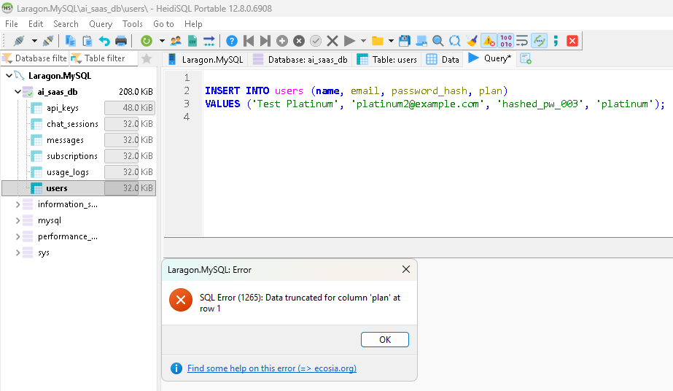

B4. Update change a user's plan from free to pro
-- Before
SELECT user_id, name, plan FROM users WHERE email = 'rafiq.islam@example.com';

-- Update
UPDATE users SET plan = 'pro' WHERE email = 'rafiq.islam@example.com';

-- After
SELECT user_id, name, plan FROM users WHERE email = 'rafiq.islam@example.com';

Expected result:


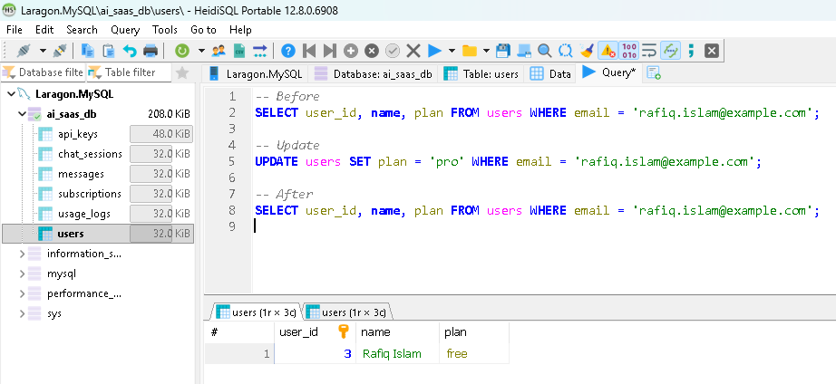

B5. Delete (referential integrity / cascade)

Step 1 Create a user with sessions and messages
-- Create test user
INSERT INTO users (name, email, password_hash, plan)
VALUES ('Cascade Test User', 'cascade.test@example.com', 'hash_cascade', 'free');

SET @uid = LAST_INSERT_ID();

-- Create a session and messages for that user
INSERT INTO chat_sessions (user_id, title) VALUES (@uid, 'Cascade Test Session');
SET @sid = LAST_INSERT_ID();

INSERT INTO messages (session_id, sender, content, tokens_used)
VALUES (@sid, 'user', 'Hello, this is a cascade test', 10),
(@sid, 'assistant', 'Sure, testing cascade delete', 12);

Step 2 Confirm rows exist before delete
SELECT * FROM chat_sessions WHERE user_id = @uid;
SELECT * FROM messages WHERE session_id = @sid;

Expected result:
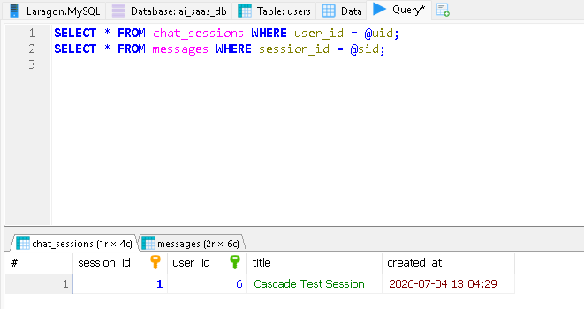

Step 3 Delete the user
DELETE FROM users WHERE user_id = @uid;

Step 4 Prove cascade worked
SELECT * FROM chat_sessions WHERE user_id = @uid; -- expect 0 rows
SELECT * FROM messages WHERE session_id = @sid; -- expect 0 rows
SELECT * FROM users WHERE user_id = @uid; -- expect 0 rows
Expected result:

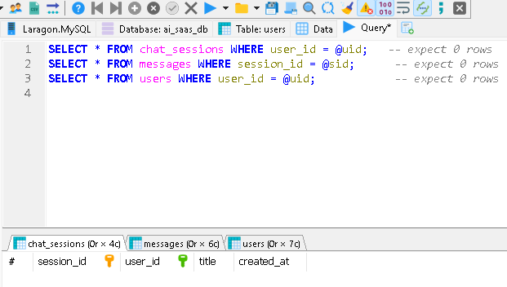

Test Report Masuduzzaman Niloy
Part C - Data Integrity & Business-Rule Queries

C1. List every user with no subscription
SELECT u.user_id, u.name, u.email
FROM users u
LEFT JOIN subscriptions s ON u.user_id = s.user_id
WHERE s.subscription_id IS NULL;
Explanation: A LEFT JOIN keeps every user row and attaches subscription data where it exists; filtering on s.subscription_id IS NULL isolates users with no matching subscription row at all useful for finding free-tier or unpaid/incomplete-signup accounts, or a sign of a broken signup flow if these users should always get a subscription row.

C2. Total tokens used and total cost per user, highest first
SELECT u.user_id, u.name,
COALESCE(SUM(ul.tokens_used), 0) AS total_tokens,
COALESCE(SUM(ul.cost), 0) AS total_cost
FROM users u
LEFT JOIN usage_logs ul ON u.user_id = ul.user_id
GROUP BY u.user_id, u.name
ORDER BY total_cost DESC;

Explanation: Aggregates all usage_logs entries per user. COALESCE ensures users with zero usage still appear (as 0), rather than being dropped. Sorting by cost descending immediately surfaces the highest-spending / heaviest-usage accounts critical for billing verification and identifying potential abuse or top customers.


C3. Chat session with the most messages, with owner's name
SELECT cs.session_id, u.name AS owner_name, COUNT(m.message_id) AS message_count
FROM chat_sessions cs
JOIN users u ON cs.user_id = u.user_id
JOIN messages m ON m.session_id = cs.session_id
GROUP BY cs.session_id, u.name
ORDER BY message_count DESC
LIMIT 1;
Explanation: Confirms message-to-session linkage is correct and identifies the most active conversation. If this returns no rows, it means no session has any messages a red flag either for empty test data or a broken insert path from the chat feature.

C4. All revoked API keys with owner's email
SELECT ak.key_id, ak.api_key, u.email, ak.status
FROM api_keys ak
JOIN users u ON ak.user_id = u.user_id
WHERE ak.status = 'revoked';
Explanation: Confirms revoked keys are still traceable to their owner for auditing (e.g., security review of who had keys revoked and why), rather than being silently deleted.

C5. Detect orphaned messages
SELECT m.message_id, m.session_id
FROM messages m
LEFT JOIN chat_sessions cs ON m.session_id = cs.session_id
WHERE cs.session_id IS NULL;
Expected result: 0 rows, if the foreign key messages.session_id chat_sessions.session_id is properly enforced (FOREIGN KEY constraint active and NOT NULL).

Explanation: A foreign key constraint physically prevents a messages row from referencing a session_id that doesn't exist in chat_sessions MySQL rejects such an INSERT outright. So, finding 0 orphans here isn't a coincidence; it's proofed the FK constraint is doing its job. (If this query did return rows, it would indicate the FK constraint is missing, disabled, or that data was loaded with FOREIGN_KEY_CHECKS = 0, bypassing referential integrity worth flagging as a serious defect.)

Part D - Transactions & Reliability

D1. Transaction with COMMIT- upgrade pro to enterprise

Step 1 - Before state
SELECT user_id, name, plan FROM users WHERE email = 'rafiq.islam@example.com';
-- expect plan = 'pro' from Part B4
SELECT * FROM subscriptions WHERE user_id = (SELECT user_id FROM users WHERE email = 'rafiq.islam@example.com');
Step 2 - Run the transaction
START TRANSACTION;

UPDATE users
SET plan = 'enterprise'
WHERE email = 'rafiq.islam@example.com';

INSERT INTO subscriptions (user_id, plan, status, start_date, price)
SELECT user_id, 'enterprise', 'active', CURDATE(), 199.99
FROM users WHERE email = 'rafiq.islam@example.com';

COMMIT;
Step 3 - After state
SELECT user_id, name, plan FROM users WHERE email = 'rafiq.islam@example.com';
SELECT * FROM subscriptions WHERE user_id = (SELECT user_id FROM users WHERE email = 'rafiq.islam@example.com');

Result:

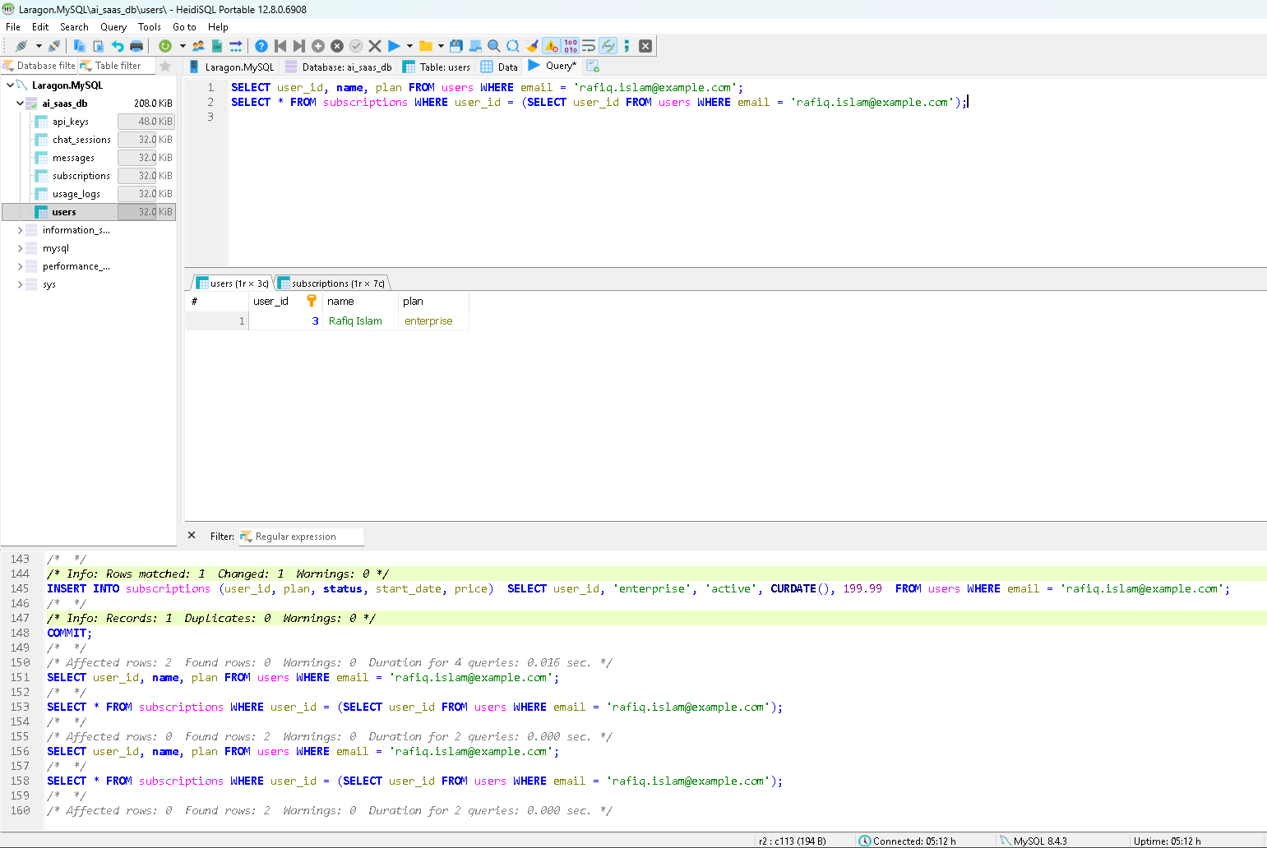

D2. Transaction with ROLLBACK - prove no change

Step 1- Before state (baseline)
SELECT user_id, name, plan FROM users WHERE email = 'rafiq.islam@example.com';
SELECT COUNT(*) AS sub_count FROM subscriptions WHERE user_id = (SELECT user_id FROM users WHERE email = 'rafiq.islam@example.com');

Step 2 - Run transaction, then roll back
START TRANSACTION;

UPDATE users
SET plan = 'free'
WHERE email = 'rafiq.islam@example.com';

INSERT INTO subscriptions (user_id, plan, status, start_date, price)
SELECT user_id, 'free', 'active', CURDATE(), 0.00
FROM users WHERE email = 'rafiq.islam@example.com';

ROLLBACK;

Step 3 - After state (prove unchanged)
SELECT user_id, name, plan FROM users WHERE email = 'rafiq.islam@example.com';
SELECT COUNT(*) AS sub_count FROM subscriptions WHERE user_id = (SELECT user_id FROM users WHERE email = 'rafiq.islam@example.com');
Result:

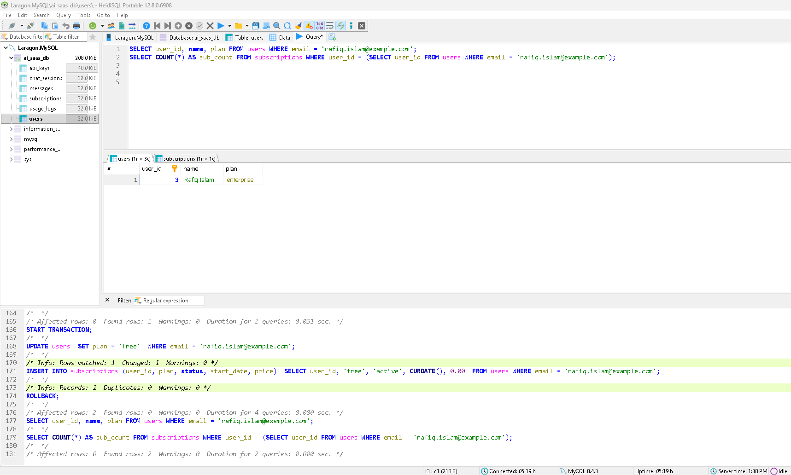

A subscription upgrade typically requires two related writes updating the user's plan AND creating/adjusting a billing/subscription record. If only one of these succeeded (e.g., the app crashes or the connection drops between the UPDATE and INSERT), the database would be left in an inconsistent state: a user marked “enterprise” with no matching subscription/billing record (or vice versa - billed for a plan the user record doesn't reflect). Wrapping both statements in a transaction guarantees atomicity: either both changes are committed together, or neither is applied at all, which is essential for financial correctness, auditability, and preventing revenue leakage or incorrect billing.

